SVAR with Cholesky decomp. Explain why.
Transformations made:
Oil/commodity here: the commodity is producer Price Index by Commodity: All Commodities (PPIACO)

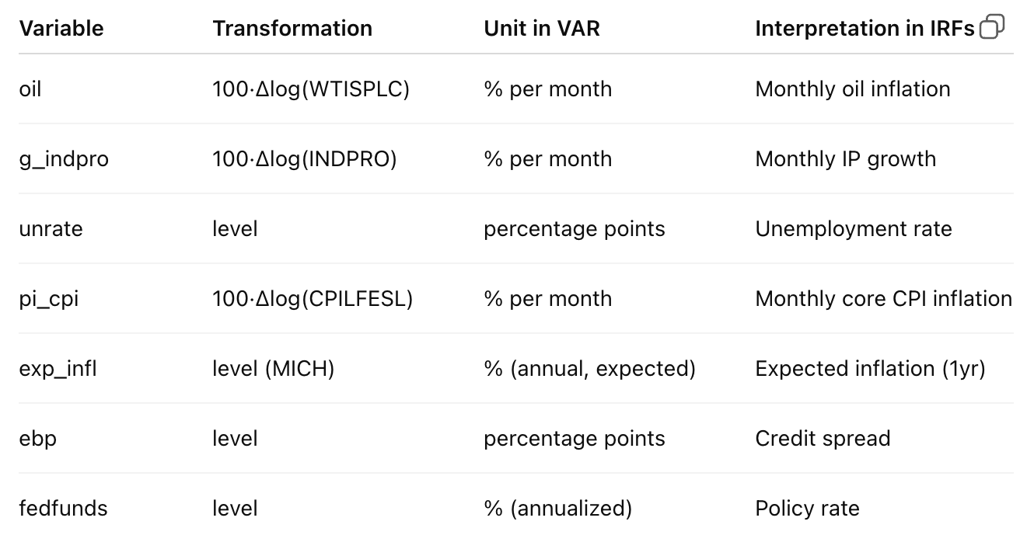
All variables except EBP is pulled through FRED. EBP is from the fed.
Always using a horizon of 36 months. Explain why- basically practical given how shocks flow through economy.

BASELINE:
1885-2007. Explain why- take out as much volatility as possible. Inflation became a lot more stable in the 80s.
Order: industrial production, unemployment rate, CPI, fed fund rate
Why?
Output first:
Production decisions are slow. Firms can’t change output instantly in response to a rate move within the same month.
Unemployment next:
Hiring/firing responds to output with a lag. Unemployment is even slower-moving than output.
Inflation after real activity:
Prices adjust sluggishly. Inflation reacts after output and labor market conditions.
Fed funds last:
The Fed can react within the month to everything above (it observes output, unemployment, inflation, expectations), but those variables do not respond instantly to a rate change.

FIRST:
CPIAUCSL VS CPILFESL
CPIAUCSL is headline CPI including food and energy.
CPILFESL is core CPI excluding those volatile components.
I get larger and more positive inflation responses when using CPIAUCSL. Reflects energy-price fluctuations that can move independently of domestic monetary policy in the short run.
Chose to use CPILFESL from there on out.

SECOND:
LAG SELECTION
AIC recommended 2. I belive that to be way to short. Imposed 6, 12. Typically of literature to do 6 or 12 given the monthly data.
With 6 lags, CPI moves smoothly and monotonically after the shock.
With 12 lags, CPI shows more short-run wiggles (up–down–up) before settling into essentially the same medium-run path.
Neither specification has an immediate, sharp inflation jump. Both imply a modest, delayed inflation response. The medium- and long-run behavior is basically the same.
When the Fed unexpectedly raises interest rates, inflation in the model does not jump right away. Instead, it moves slowly and only rises a bit later. A price puzzle would be inflation jumping immediately and strongly after the rate hike, and that’s not happening here.
Chose to use 6 lags from there on out.

THIRD:
ADDING OIL/COMMODITY PRICES
Bernanke-Gertler Style VAR Ordering says oil/commodity is first. Tried with WTI and commodity. Put it first bc move fast, largely exogenous at monthly frequency and the Fed can react to them immediately.
Explain why put this as an endogenous var vs doing a VARX.
Broad commodity price index is a better “catch-all” proxy for near-term inflation pressure than one specific commodity, so it more directly targets the classic VAR “information” problem.
WTI (oil) is the most common single-series choice and helps if the sample has energy-driven inflation episodes.
Because core CPI excludes food and energy, I use commodity price index as an information variable to capture short-run cost pressures and inflation news observed by policymakers.
Chose to use oil prices from there on out.

FOURTH:
ADDING FINANCIAL VARIABLE: EXCESS BOND PREMIUM
Gilchrist and Zakrejsek 2012
EBP is the part of corporate bond spreads that is not explained by default risk or expected losses.
Think of EBP as financial stress / risk appetite. It moves faster than real activity, but its not purely exogenous like commodities, and the Fed observes it in real time and reacts to it. So ordered to be right before Fed funds.
EBP responds positively and persistently to a policy tightening. Fed tightens then risk appetite falls then credit spreads widen. The EBP response is smooth, hump-shaped, and significant early on.
Chose to keep EBP.

FIFTH:
ADDING INFL EXPECTATIONS

With expectations included:
-Policy shocks are less contaminated by “Fed reacting to expected inflation”
-The monetary policy shock becomes closer to an exogenous tightening
Inflation expectations go second in the ordering. They react quickly to commodity prices, oil shocks, macro news. Are forward-looking beliefs, not policy instruments. Are influenced by many things before the Fed acts.
Results in the Fed tightens in response to inflationary news, and expectations adjust immediately.
After an unexpected monetary tightening, inflation expectations rise immediately, reflecting that the Federal Reserve is reacting to information about future inflation rather than current prices. Commodity prices and financial conditions also respond quickly, with commodity prices capturing short-run cost pressures and the excess bond premium increasing as credit conditions tighten. Real activity responds only modestly at first, while unemployment rises gradually with a delay, consistent with standard monetary transmission.
Most importantly, core CPI does not jump on impact. Instead, it adjusts slowly and modestly over time, following the earlier movements in expectations and financial conditions. This sequencing, expectations first and prices later, indicates that inflation responds with inertia rather than exhibiting a traditional price puzzle, and is consistent with forward-looking monetary policy and sluggish price adjustment.

SIXTH
ROBUSTNESS
With that final set up, tried different ordering, lags =12, etc and Cpi doesn’t flip.

HIGH FREQUENCY IV-SVAR:
In addition to a recursive (Cholesky) identification, I identify monetary policy shocks using an external instrument constructed from high-frequency financial market data. Specifically, I use a series of monetary policy surprises measured from changes in interest-rate futures in narrow windows around FOMC announcements. Because these surprises are measured over very short time intervals, they plausibly isolate unexpected monetary policy news and are unlikely to be contaminated by concurrent macroeconomic developments. Using Gertler and Karadi (2015) instrument from 1990m01 to 2012m06.
High-frequency monetary policy surprises are aggregated to the monthly level by summing all announcement-window surprises within each month, producing a single measure of unexpected policy news consistent with the frequency of the VAR.
Need to explain relevance and exclusion restriction?
Estimate a reduced-form VAR containing commodity prices, inflation expectations, real activity, unemployment, core CPI inflation, the EBP and the federal funds rate. Then use the high-frequency surprise series as an external instrument to identify the monetary policy shock via a proxy SVAR (SVAR-IV) approach.
In the data, the instrument strongly predicts the residual in the policy-rate equation, with a first-stage F-statistic well above conventional thresholds, supporting its relevance.
First-stage F-stat (u_fedfunds ~ instrument): 27.5091 on df( 1 , 197 )
Impact vector (h=0) normalized so fedfunds = 1:
oil exp_infl g_indpro unrate pi_cpi ebp fedfunds
4.0297 0.1992 -0.0677 -0.2284 -0.1217 0.3996 1.0000
The monetary policy shock is normalized such that it raises the federal funds rate by one unit on impact. Impulse responses are then computed using the VAR’s moving-average representation, without relying on recursive ordering assumptions for identification.
Results: realized core CPI inflation does not exhibit a sharp or persistent increase following the policy shock!! Explain why that would be.

